Journal for project puzzle

* Find the 4 point of a piece and calculate the number of point in this envelope
* This, according to our hypothesis should be the corner envelope

On the first piece:

Corners:

UR 532 720 line : 88

UL 259 710 line : 85

DL 239 460 line: 24

DR 516 442 line: 22

Since our calculation is discreet (pixel coordinate are in integer) we might have some error sometime if two chosen point are vertical or horizontal to each other.

Some code optimization can be done on the SEG function

Next step : try to make the piece with point inside. 

So we can avoid to count such a set. In fact, every surface that are out of the piece should subtract some weight to the calculated set.

The piece while be define by to set of point calculated at the same time, the contour points, and the inside points. The contour point will be used as a set for the four corner, and the inside point will be used for ponderation and give a grade to the set of corners.

I have to optimize the function Intersect that count how many point are in a convexe envelope. Right now I am calculating every time the vector.

I realize how much noise was in the contouring data.



 

Now we want to have in points to choose the right corner

The piece in define by two types of point, the in point as below and the limit points.





We apply the same algo as before

Will try to confirm that the closer you are from the four corner the more point are in.



I have to fix the function Intersect_Vert_Seg. There are two cases where the count is not right. The first one is when the segment is horizontal, the second one having the point and the nod vertical to each other.

As I am looking at this up-graph, I am thinking about an other way to crack the problem, I would like to see the graph of the variation of the tangeant along the contour. Something sharp is happening at the corner, that never happen somehere else.

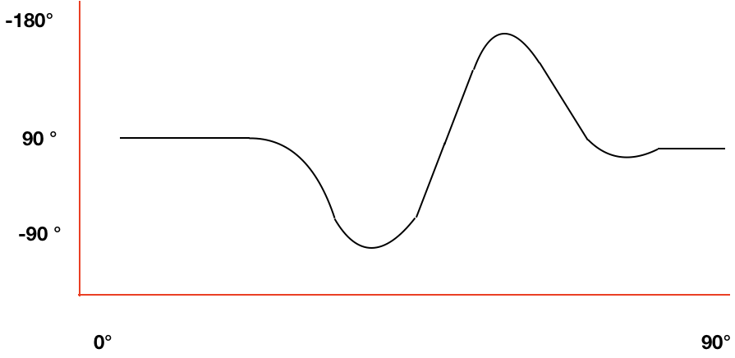

This second approach is pretty interesting. We can analis the contour from the piece picture.

We take the center line of the image, and detect the first point of the contour with the technic we already use.

ie. The changement in intensity.

Once we get that point, we start to rotate a segment from that point. The other end of the segment is measuring the intensity change.

The radius of the magenta circle has to be smaller than the second smallest radius define in a piece. Considering that the corner will always be the smallest radius of curvature.

With this technic we will have in one analisis the contour and the variation of the radius of curvature along the contour. Analising the last one we should be able to detect the corner of the piece.

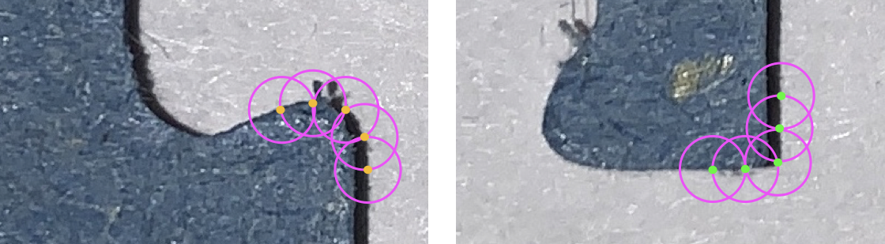

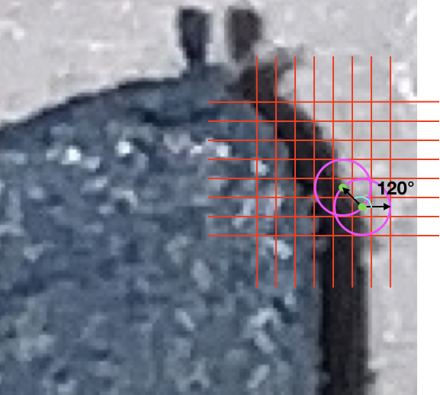

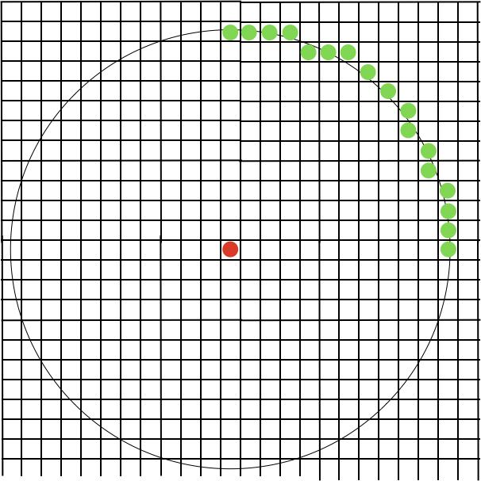

Figure 1 definition of a finite circle with pixels

We define a changing radius circle around a contour point to find the next point everything is done CCW.

The method seems to work pretty well.

 

Figure 2 piece 1- Circle contour method

Quite sensitive to noise :



Figure 3 before modify



Figure 4 After modify

